11/25/2025
TEAM 4
GABRIEL ROSAS, KYAN HAMILTON, BENJAMIN HAASE
<EXSTRUCTA> SYSTEM REQUIREMENTS DOCUMENT

Table of Contents
Introduction 2
Description Model 2
Class Diagram 4
Use Case Diagram 4
Use Case Scenarios 4
System Sequence Charts 4

Introduction KH
The purpose of this document is to organize the Exstructa project requirements into a single, structured source. It includes key elements such as the input, output, processes, performance, and security for Exstructa features, created by Team Legion. This document ensures that all stakeholders share a clear understanding of what the system must deliver and how its success will be measured.
Exstructa aims to simplify workplace collaboration by unifying core communication features into one platform. The application will provide tools for direct messaging, event planning, and contact list, eliminating the need for multiple separate applications. By centralizing these functions, Exstructa enhances workflow efficiency while reducing costs associated with maintaining several software services.
This introduction establishes the context and purpose of the requirements that follow, guiding the design, development, and validation of the Exstructa system. By consolidating essential communication functions that are typically spread across separate applications, the system will focus on providing a seamless, accessible, and efficient user experience for workplace teams.

Description Model BH

- Servers - Much like Discord and Slack, Exstructa will have different servers which will include both text and voice channels. The owner(person who created the server) of the server will be able to add whoever they want. Text channels and voice channels are able to be seen by everybody but not everybody can use them depending on their permissions. Servers will have the ability to have other applications added to it like in Slack. Moderators of the servers along with automatic and manual moderation by Exstructa assets will be used.
  - Input - Owner provides information when creating or managing a server. Name, channel names, user id, chat messages
  - Output - Server information, member information, Channel feed
  - Processes - Includes Text channels, and voice channels, along with the ability to add apps like calculators or other calendar versions. There will also be automatic filtering done by Exstructa software.
  - Performance - Depends on the users internet connection to internet and Exstructa servers.
  - Security - Server moderators are to be determined by the owner of the server. Server moderators will be able to silence, block, and ban content and users at their own discretion. Exstructa moderators will also be active in making sure security is upheld.

- Server Roles - Owners will also be able to create roles allowing them to set permissions for their users and to organize their server to maintain order. In these servers there will also be a list member and their roles allowing you to see who is in the server and who is currently online
  - Input - Owner creates and names a role they can either make on their own or a role they can pick from, inputs role settings, saves role settings, and assigns roles to certain members.
  - Output - Members can be renamed to that role and have the abilities assigned to that role.
  - Processes - Different levels of permissions which can be granted to a role of an admins or owners choice. Provides endless possibilities for them to make.
  - Performance - determined by what permissions are granted to the role. Permissions range from someone who can only pin to someone who can create channels and block or ban people from the server
  - Security - Only the owner is allowed to access role management and has the authority to change any of the settings.

- Direct Messaging - This is meant to be like E-mail since it is a more formal environment. It will look like Google direct messaging in Gmail. In Exstructa you can either choose a contact or input someone's email to start a direct message. You can also add other people to that direct message to make it a group chat. Users can block or remove people from direct messages if they want to.Direct Messages include attachments such as text file or picture. The text chats also include emojis, formatting options, and audio or video messages.
  - Input - User must input a contact or another user’s email to begin a direct message. Privacy and security preferences for contacts such as the ability to hide personal information from certain contacts that you have added, the ability to block users and report them if they violated Exstructa terms.
  - Output - User can message each other and start individual voice calls
  - Processes - easy messaging individual people or groups of people. Users have the ability to turn on a filter for text chat.
  - Performance - response time depends on the users connection to their network
  - Security - Users have the ability to block unwanted contacts and they can also report those unwanted contacts to Exstructa staff. There will be a report button with the option of a quick report or a ticket report. A quick report will use A.I. to determine if the person needs to be banned or not. A ticket report will be submitted to a real person working for Exstructa so that they can manually review the problem.

- Shared Calendar -This feature is a server-wide calendar. It has events and dates important to the server to help in the organization of work. The calendar is not only for server-wide events, though, since individual people and channel-wide events can also be added and will be seen only to those with permissions to do so.
  - Input - User customized events including title, description and time of when the event will happen
  - Output - Displays all members customized events on one calendar
  - Processes - Users can add events to a server calendar or individual calendar of their choice. Filters and moderation are set by the server admin or owner and can be given an automatic filter engineered by Exstructa
  - Performance - Feed is updated and event changes are saved through Exstructa servers
  - Security - Moderation will be done by server admins and server owner to set rules, permissions and limitations for calendar use and who can use it

- Contact - Our app will include a list of contacts which consist of saved users and recipients. This list updates when a message, email or meeting is sent to another user. The send feature allows you to send an email to multiple people at once by entering the names of the contact list. To create a “New contact list," enter a name and description, and then add individual contacts by typing their names and email addresses.
  - Input - User customized contacts which includes, name, description, and email address of the person
  - Output - User contact list with all contacts inputted by the user
  - Processes - Users can add anybody they want to contact if they have an email address for this person. Name and description can be made by the user
  - Performance - Instant notifications for the user once they are added to someone's contact list. Notifications and contact list updates occur when an email, message, or meeting is sent.
  - Security - Moderation settings for the user like blocking or muting people who they do not want to interact with.

Class Diagram GKRM
File not included in this document.

Use Case Diagram GKRM
Create a Use Case Diagram for all of the "uses" of your system. This diagram may be included as a separate file – it does not need to be inserted into this Word document.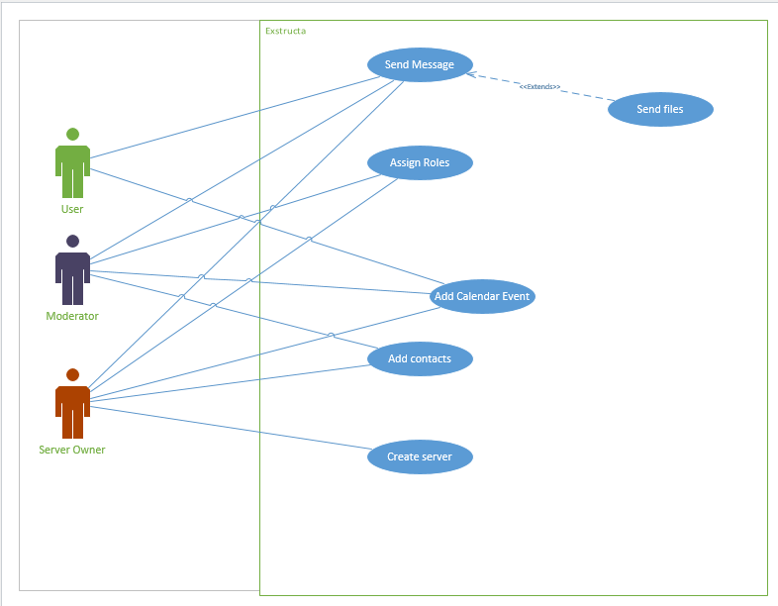

Use Case Scenarios KH
File not included in this document.

System Sequence Charts BH
File not included in this document.

